A Recipe For:

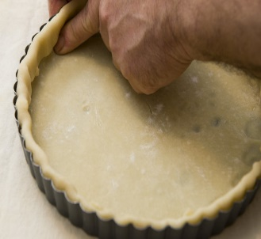 

# Plain Pastry

**From the Kitchen of:** Mom

**Servings:** 1 pie

**Prep Time:** **Bake Time:** **Bake Temp:**

**Ingredients:** For single-crust pie or 4 to 6 tarts

* 1 ½ cups sifted all-purpose flour
* ½ tsp salt
* ½ cup shortening
* 4 to 5 Tbsp cold water

For one 8, 9, or 10 inch double crust or lattice-top pie

* 2 cups sifted all-purpose flour
* 1 tsp salt
* 2/3 cups shortening
* 5 – 7 Tbsp cold water

Sift flour and salt together: cut in shortening with pastry blender til pieces are the size of small peas. Sprinkle 1 tablespoon water over part of mixture. Gently toss with fork: push to side of bowl. Repeat til all is moistened. Form into a ball. (for double-crust and lattice-top pies, divide dough for lower and upper crust and form into balls.) Flatten on lightly floured surface by pressing with edge of hand 3 times across in both directions. Roll from center to edge til 1/8inch thick.

Fit pastry into pie plate.